**Accessibility testing and fixes.**

**Accessibility testing**

I used light house to accessibility test my website.

(Problem 1 (Desktop))

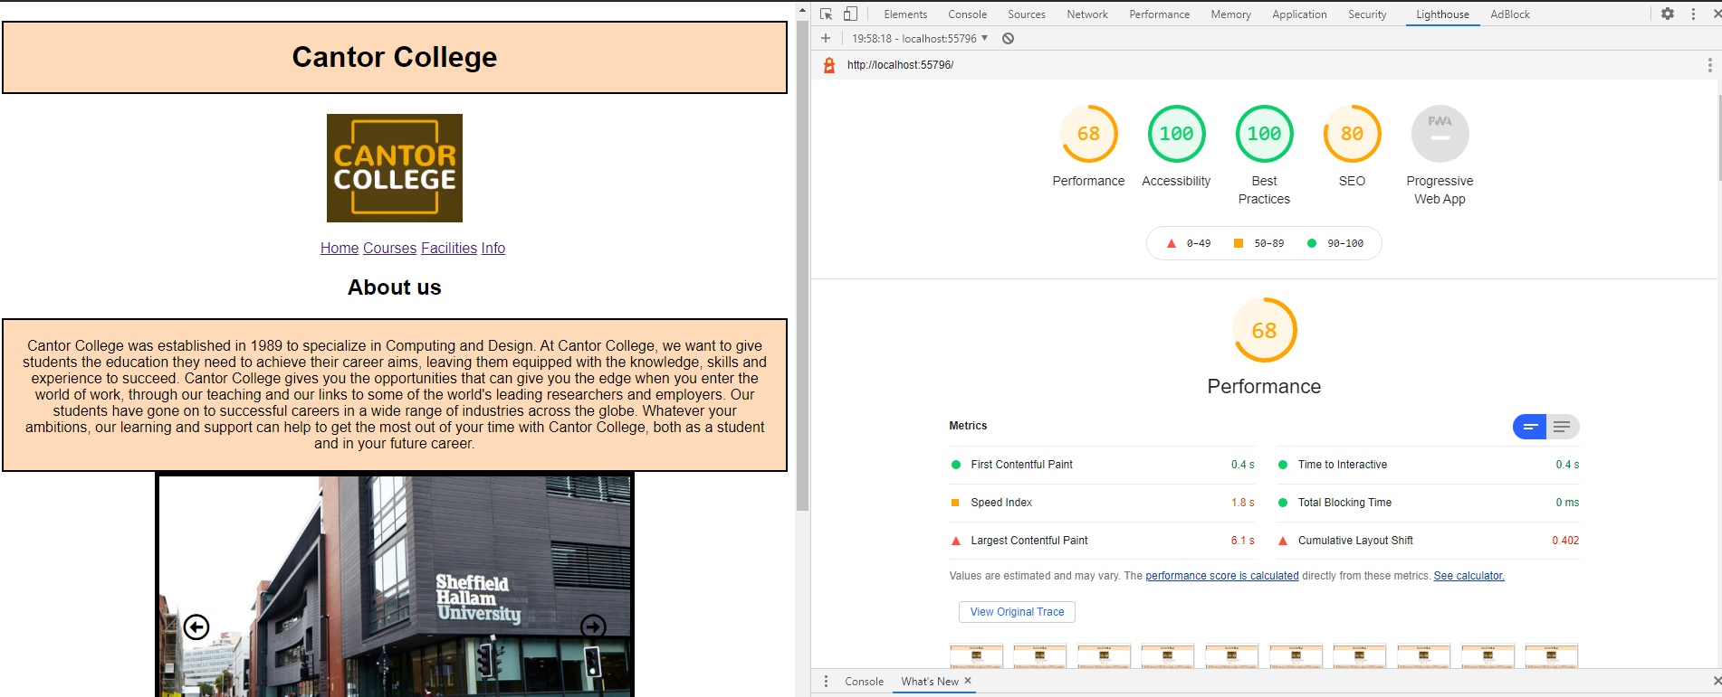

My web page accessibility score was poor as a got 68 in performance and I identified the issue as the image sizes on the images I am using on the homepage image slider as being too large.

(problem 1 (Desktop))

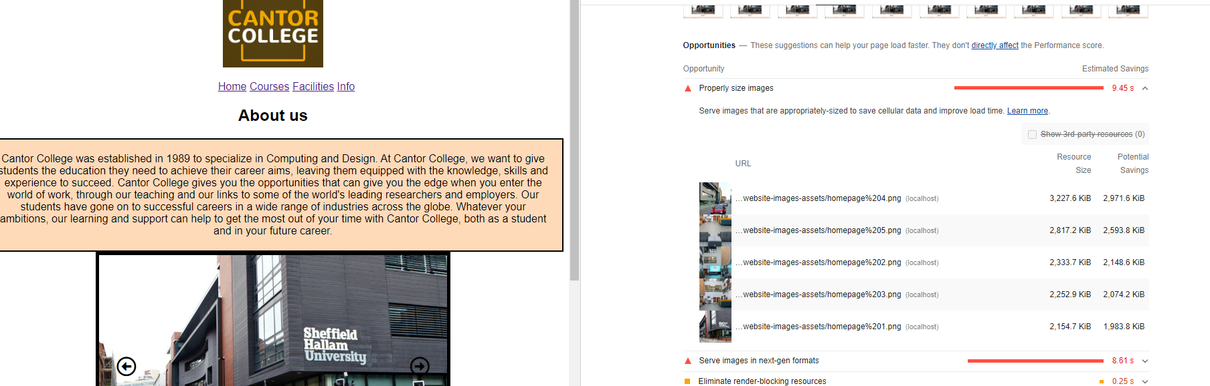

**Fixes made due to accessibility testing.**

(fix 1(Desktop))

Firstly, I went and resized all five of the homepage image slider images what was causing the issue on this website 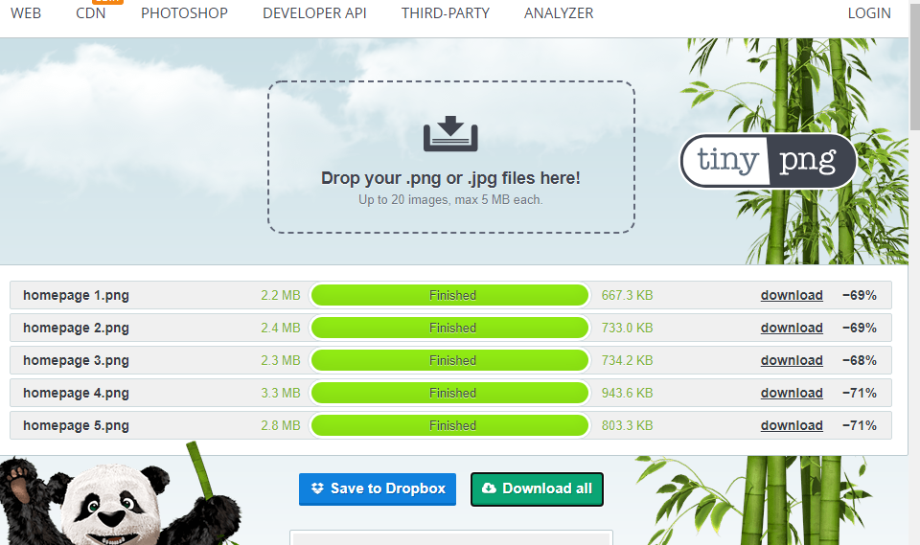

I uploaded the images into the wwwroot folder and replaced the old images which gave an improvement of 10 as performance went from 68 to 78, however I could get the images smaller to increase performance and accessibility.

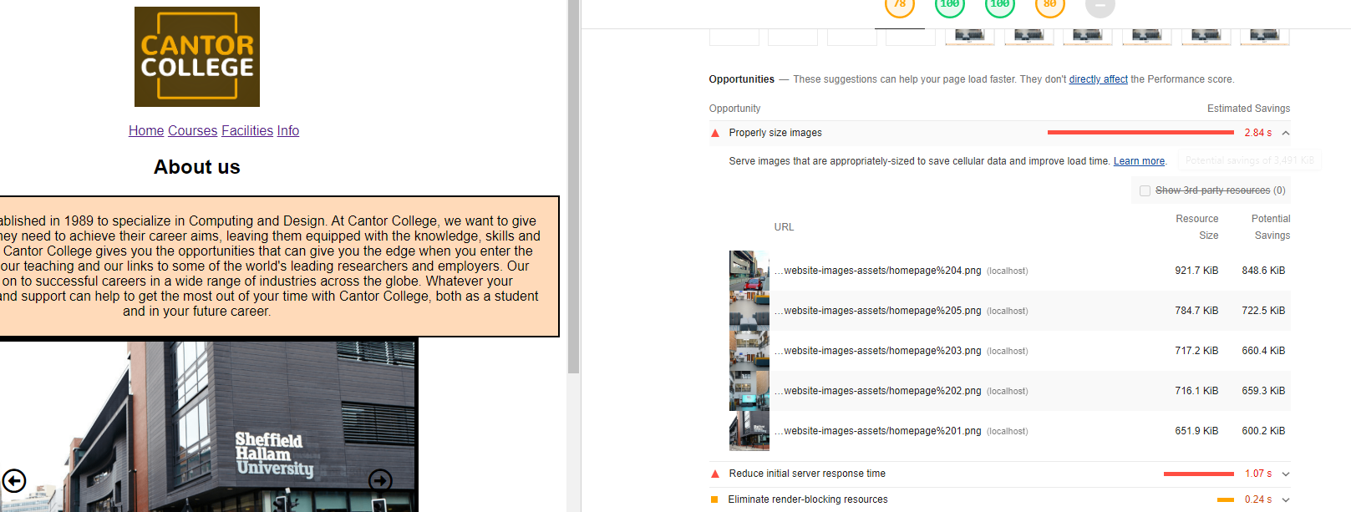(fix 1)

(Problem 2)

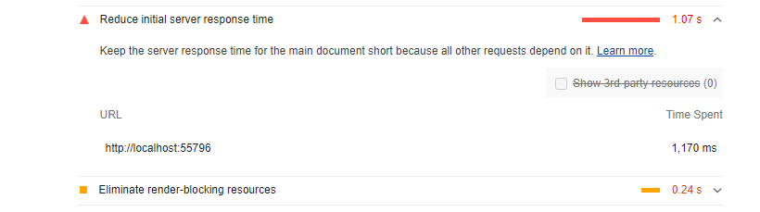There was an issue with the responsive time and server speed ‘local host’ which is my computer so I could really improve that as in reality if it were a company or something, they would have dedicated servers for their website so that the speeds are much higher however there was no real fix for this that I could do.

**Accessibility testing**

(mobile)

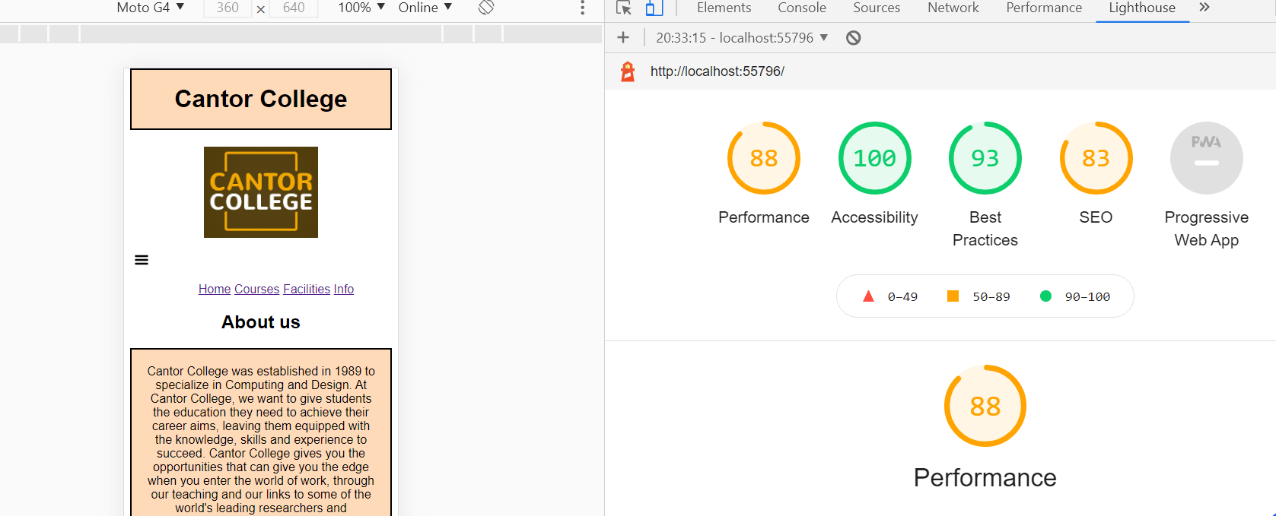On mobile the accessibility is pretty good, so I did not see any area specifically to improve the accessibility on.

Looking further into the design it showed that yet again server response time is an issue as it was of course with the desktop version and I cannot improve on that.



Furthermore, I showed that my images specially the image sizes of the homepage image slider images were too big however I already compressed them and reduced the size of them as I showed earlier on with the desktop version.



Finally, I tested the accessibility of my page by zooming in by 200% to see if the visibility and clarity remains and it did.



In conclusion both the mobile and desktop versions of my website have very good accessibility and provide good clarity for all users as they have very good scores shown by lighthouse and hopefully will help provide a good user experience for all users.